1970
(a) What is the pH of a 2.0 molar solution of acetic acid. K_{a} acetic acid = 1.8x10⁻⁵
(b) A buffer solution is prepared by adding 0.10 liter of 2.0 molar acetic acid solution to 0.1 liter of a 1.0 molar sodium hydroxide solution. Compute the hydrogen ion concentration of the buffer solution.
(c) Suppose that 0.10 liter of 0.50 molar hydrochloric acid is added to 0.040 liter of the buffer prepared in (b). Compute the hydrogen ion concentration of the resulting solution.
Answer:
(a) CH₃COOH(aq) <=> H⁺(aq) + CH₃COO⁻(aq)
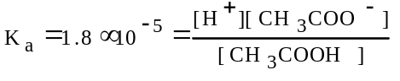
[H⁺] = [CH₃COO⁻] = X
[CH₃COOH] = 2.0 - X, X << 2.0, (2.0- X) = 2.0
1.8x10⁻⁵ = 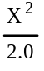
X = 6.0x10⁻³ = [H⁺]; pH = -log [H⁺] = 2.22
(b) 0.1 L x 2.0 mol/L = 0.20 mol CH₃COOH
0.1 L x 1.0 mol/L = 0.10 mol NaOH
the 0.10 mol of hydroxide neutralizes 0.10 mol CH₃COOH with 0.10 mol remaining with a concentration of 0.10 mol/0.20 L = 0.5 M. This also produces 0.10 mol of acetate ion in 0.20 L, therefore, [CH₃COO⁻] = 0.50 M.
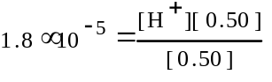
[H⁺] = 1.8x10⁻⁵ = pH of 4.74
(c) [CH₃COOH]_{o} = [CH₃COO⁻]_{o}
= 0.50 M x 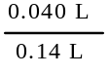 = 0.143 M
[H⁺]_{o} = 0.50 M x 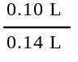 = 0.357 M
the equilibrium will be pushed nearly totally to the left resulting in a decrease of the hydrogen ion by 0.143M. Therefore, the [H⁺]_{eq} = 0.357M - 0.143M = 0.214M.

1970
H₃PO₂,H₃PO₃, and H₃PO₄ are monoprotic, diprotic and triprotic acids, respectively, and they are about equal strong acids.
HClO₂, HClO₃, and HClO₄ are all monoprotic acids, but HClO₂ is a weaker acid than HClO₃ which is weaker than HClO₄. Account for:
(a) The fact that the molecules of the three phosphorus acids can provide different numbers of protons.
(b) The fact that the three chlorine acids differ in strengths.
Answer:
(a) the structure for the three acids are as follows:
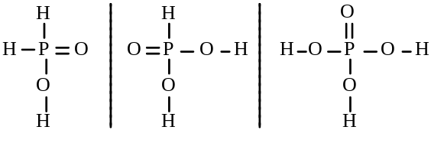
The hydrogen atom(s) bonded directly to the phosphorus atom is/are not acidic in aqueous solution; only those hydrogen atoms bonded to the oxygen atoms can be released as protons.
(b) The acid strength is successively greater as the number of oxygen atoms increases because the very electronegative oxygen atoms are able to draw electrons away from the chlorine atom and the O-H bond. This effect is more important as the number of attached oxygen atoms increases. This means that a proton is most readily produced by the molecule with the largest number of attached oxygen atoms.

1970
A comparison of the theories Arrhenius, Bronsted and Lewis shows a progressive generalization of the acid base concept. Outline the essential ideas in each of these theories and select three reactions, one that can be interpreted by all three theories, one that can be interpreted by two of them, and one that can be interpreted by only one of the theories. Provide these six interpretations.
Answer:
Arrhenius
acid = produce H⁺ ions in aqueous solution
base = produce OH⁻ ions in aqueous solution
Bronsted-Lowry
acid = proton (H⁺) donor; base = proton acceptor
Lewis
acid = e- pair acceptor; base = e- pair donor
Examples:
Interpreted by all three
HCl + H₂O -->H⁺(aq) + Cl⁻(aq)
NaOH + H₂O --> Na⁺(aq) + OH⁻(aq)
Interpreted by two
NH₃ + HCl <=> NH₄⁺ + Cl⁻
Interpreted by only one
BF₃ + NH₃ --> F₃B:NH₃

1972 (repeated in gases topic)
A 5.00 gram sample of a dry mixture of potassium hydroxide, potassium carbonate, and potassium chloride is reacted with 0.100 liter of 2.00 molar HCl solution
(a) A 249 milliliter sample of dry CO₂ gas, measured at 22ºC and 740 torr, is obtained from this reaction. What is the percentage of potassium carbonate in the mixture?
(b) The excess HCl is found by titration to be chemically equivalent to 86.6 milliliters of 1.50 molar NaOH. Calculate the percentages of potassium hydroxide and of potassium chloride in the original mixture.
Answer:
(a) K₂CO₃ + 2 HCl -->CO₂ + 2 KCl + H₂O
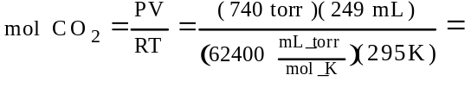
= 0.0100 mol CO₂
0.10 mol CO₂ × 1 mol K₂CO₃ / 1mol CO₂ × 138.2 g K₂CO₃ /1 mol K₂CO₃ =
=1.38 g K₂CO₃
1.38 g K₂CO₃/5.00 g mixture × 100% = 27.6% K₂CO₃
(b) orig. mol HCl = 0.100 L × 2.00M = 0.200 mol
reacted with K₂CO₃ = 0.020 mol
excess HCl = 0.0866L × 1.50M = 0.130 mol
mol HCl that reacted w/KOH = 0.050 mol
0.050 mol KOH = 2.81 g = 56.1% of sample
the remaining KCl amounts to 16.3%

1972
Given a solution of ammonium chloride. What additional reagent or reagents are needed to prepare a buffer from the ammonium chloride solution?
Explain how this buffer solution resists a change in pH when:
(a) Moderate amounts of strong acid are added.
(b) Moderate amounts of strong base are added.
(c) A portion of the buffer solution is diluted with an equal volume of water.
Answer:
Since ammonium chloride is a salt of a weak base, the weak base is needed, ammonia, NH₃.
(a) When moderate amounts of a strong acid, H⁺, are added, the ammonia reacts with it. The concentration of the hydrogen ion remains essentially the same and therefore only a very small change in pH.
NH₃ + H⁺ <=> NH₄⁺
(b) When moderate amounts of a strong base, OH⁻, are added, the ammonium ion reacts with it. The concentration of the hydrogen ion remains essentially the same and therefore only a very small change in pH.
NH₄⁺ + OH⁻ <=> NH₃ + H₂O
(c) By diluting with water the relative concentration ratio of [NH₄⁺]/[NH₃] does not change, therefore there should be no change in pH.

1973
A sample of 40.0 milliliters of a 0.100 molar HC₂H₃O₂ solution is titrated with a 0.150 molar NaOH solution. K_{a} for acetic acid = 1.8x10⁻⁵
(a) What volume of NaOH is used in the titration in order to reach the equivalence point?
(b) What is the molar concentration of C₂H₃O₂⁻ at the equivalence point?
(c) What is the pH of the solution at the equivalence point?
Answer:
(a) M_{a}V_{a}=M_{b}V_{b}
(0.100M)(40.0 mL) = (0.150M)(V_{b})
V_{b} = 26.7 mL
(b) acetate ion is a weak base with
K_{b}=K_{w}/K_{a} = 1.0×10⁻¹⁴/1.8×10⁻⁵ = 5.6×10⁻¹⁰
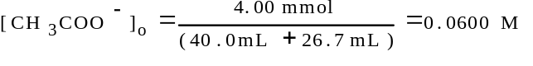
[CH₃COO⁻]_{eq} = 0.600M -X
[OH⁻] = [CH₃COOH] = X
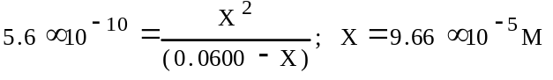
0.0600M-9.66×10⁻⁵M = 0.0599M [CH₃COO⁻]_{eq}
(c) 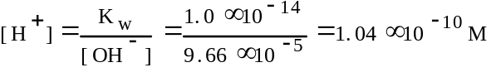
pH = -log [H⁺] = -log(1.04×10⁻¹⁰) = 9.98

1974 A
A solution is prepared from 0.0250 mole of HCl, 0.10 mole propionic acid, C₂H₅COOH, and enough water to make 0.365 liter of solution. Determine the concentrations of H₃O⁺, C₂H₅COOH, C₂H₅COO⁻, and OH⁻ in this solution. K_{a} for propionic acid = 1.3x10⁻⁵
Answer:
C₂H₅COOH + H₂O <=> C₂H₅COO⁻ + H₃O⁺
[C₂H₅COO⁻] = X
[C₂H₅COOH] = (0.10mol/0.365L) - X
[H₃O⁺] = (0.0250mol/0.365L) + X
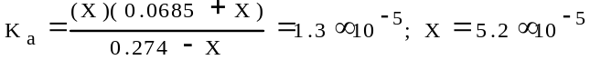
[C₂H₅COO⁻] = 5.2×10⁻⁵M; [C₂H₅COOH] = 0.274M
[H₃O⁺] = 0.0685M;
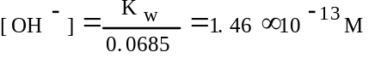

1975 A
(a) A 4.00 gram sample of NaOH(s) is dissolved in enough water to make 0.50 liter of solution. Calculate the pH of the solution.
(b) Suppose that 4.00 grams of NaOH(s) is dissolved in 1.00 liter of a solution that is 0.50 molar in NH₃ and 0.50 molar in NH₄⁺. Assuming that there is no change in volume and no loss of NH₃ to the atmosphere, calculate the concentration of hydroxide ion, after a chemical reaction has occurred. [Ionization constant at 25ºC for the reaction NH₃ + H₂O -->NH₄⁺ + OH⁻; K = 1.8x10⁻⁵]
Answer:
(a) 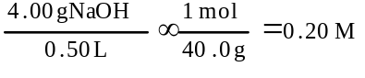
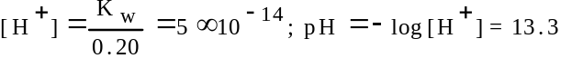
(b) 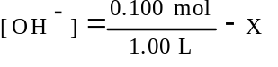
[NH₄⁺] = 0.50M - X; [NH₃] = 0.50M + X
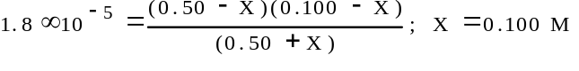
using the Henderson-Hasselbalch equation
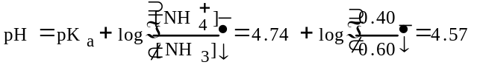

1975
Reactions requiring either an extremely strong acid or an extremely strong base are carried out in solvents other than water. Explain why this is necessary for both cases.
Answer:
Water is amphoteric and can behave either as an acid in the presence of a strong base or as a base in the presence of strong acid.
Water also undergoes autoionization.

1976
H₂S + H₂O <=> H₃O⁺ + HS⁻ K₁ = 1.0x10⁻⁷
HS⁻ + H₂O <=> H₃O⁺ + S²⁻ K₂ = 1.3x10⁻¹³
H₂S + 2 H₂O <=> 2 H₃O⁺ + S²⁻ K = 1.3x10⁻²⁰
Ag₂S(s) <=> 2 Ag⁺ + S²⁻ K_{sp}= 5.5x10⁻⁵¹
(a) Calculate the concentration of H₃O⁺ of a solution which is 0.10 molar in H₂S.
(b) Calculate the concentration of the sulfide ion, S²⁻, in a solution that is 0.10 molar in H₂S and 0.40 molar in H₃O⁺.
(c) Calculate the maximum concentration of silver ion, Ag⁺, that can exist in a solution that is 1.5×10⁻¹⁷ molar in sulfide ion, S²⁻.
Answer:
(a) H₂S + H₂O <=> H₃O⁺ + HS⁻
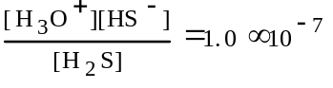
let X = [H₃O⁺] = [HS⁻]
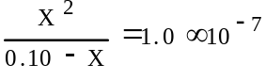
X ïï 0.10; X = 1.0x10⁻⁴ M = [H₃O⁺]
(b) H₂S + 2 H₂O <=> 2 H₃O⁺ + S²⁻
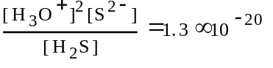
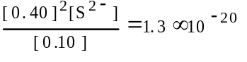 ; [S²⁻] = 8.1×10⁻²¹M
(c) Ag₂S(s) <=> 2 Ag⁺ + S²⁻; [Ag⁺]²[S²⁻] = 5.5×10⁻⁵¹
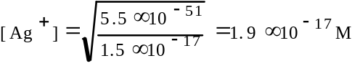

1977
The value of the ionization constant, K_{a}, for hypochlorous acid, HOCl, is 3.1×10⁻⁸.
(a) Calculate the hydronium ion concentration of a 0.050 molar solution of HOCl.
(b) Calculate the concentration of hydronium ion in a solution prepared by mixing equal volumes of 0.050 molar HOCl and 0.020 molar sodium hypochlorite, NaOCl.
(c) A solution is prepared by the disproportionation reaction below. Cl₂ + H₂O --> HCl + HOCl
Calculate the pH of the solution if enough chlorine is added to water to make the concentration of HOCl equal to 0.0040 molar.
Answer:
(a) HOCl + H₂O <=> H₃O⁺ + OCl⁻
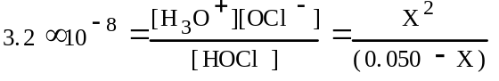
X = [H₃O⁺] = 4.0x10⁻⁵M
(b) HOCl + H₂O <=> H₃O⁺ + OCl⁻
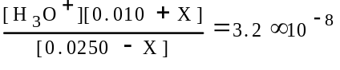 ; X << 0.010
X = [H₃O⁺] = 8.0x10⁻⁸M
(c) Cl₂ + H₂O --> HCl + HOCl
[HOCl] = [HCl] = 0.0040M
HCl as principal source of H₃O⁺
pH = -log[H₃O⁺] = 2.40

1978 A
A 0.682 gram sample of an unknown weak monoprotic organic acid, HA was dissolved in sufficient water to make 50 milliliters of solution and was titrated with a 0.135 molar NaOH solution. After the addition of 10.6 milliliters of base, a pH of 5.65 was recorded. The equivalence point (end point) was reached after the addition of 27.4 milliliters of the 0.135 molar NaOH.
(a) Calculate the number of moles of acid in the original sample.
(b) Calculate the molecular weight of the acid HA.
(c) Calculate the number of moles of unreacted HA remaining in solution when the pH was 5.65.
(d) Calculate the [H₃O⁺] at pH = 5.65
(e) Calculate the value of the ionization constant, K_{a}, of the acid HA.
Answer:
(a) at equivalence point, moles HA = moles NaOH
= M_{b}V_{b} = (0.0274 L)(0.135 M) = 3.70x10⁻³ mol HA
(b) 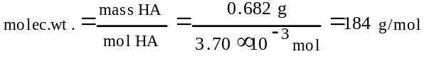
(c) HA + OH⁻ --> A⁻ + H₂O
initial: 0.00370 mol
added: (0.0106L)(0.135M) = 0.00143 mole
remaining: (0.00370 - 0.00143) = 0.00227 mol
(d) pH = -log[H₃O⁺]; [H₃O⁺] = 10^{-pH} = 10^{-5.65}
= 2.2x10⁻⁶M
(e) 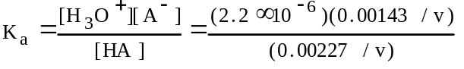
= 1.4x10⁻⁶

1978 D
Predict whether solutions of each of the following salts are acidic, basic, or neutral. Explain your prediction in each case
(a) Al(NO₃)₃ (b) K₂CO₃ (c) NaBr
Answer:
(a) acidic; Al³⁺ + H₂O <=> AlOH²⁺ + H⁺;
hydrolysis of Al³⁺;
Al(OH₂)_{n}³⁺ as Bronsted acid, etc.
(b) basic; CO₃²⁻ + H₂O <=> HCO₃⁻ + OH⁻ ; or
hydrolysis of CO₃²⁻ as conjugate to a weak acid, etc.
(c) neutral; Na⁺ from strong base; Br⁻ from strong acid

1979 B
A solution of hydrochloric acid has a density of 1.15 grams per milliliter and is 30.0% by weight HCl.
(a) What is the molarity of this solution of HCl?
(b) What volume of this solution should be taken in order to prepare 5.0 liters of 0.20 molar hydrochloric acid by dilution with water?
(c) In order to obtain a precise concentration, the 0.20 molar hydrochloric acid is standardized against pure HgO (molecular weight = 216.59) by titrating the OH- produced according to the following quantitative reaction.
HgO(s) + 4 I⁻ + H₂O --> HgI₄²⁻ + 2 OH⁻
In a typical experiment 0.7147 grams of HgO required 31.67 milliliters of the hydrochloric acid solution for titration. Based on these data what is the molarity of the HCl solution expressed to four significant figures.
Answer:
(a) 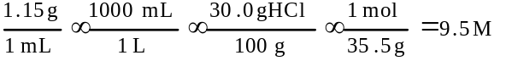
(b) M_{f}V_{f} = M_{i}V_{i}
(0.20M)(5.0L) = (9.5M)(V)
V = 0.11 L
(c) 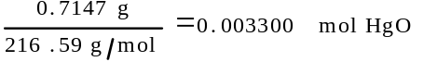
mol OH⁻ prod. = 2 (mol HgO) = 0.006600 mol
mol HCl req. = mol OH⁻ prod. = 0.006600 mol
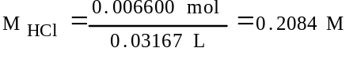

1979 D
NH₄⁺ + OH⁻ <=>NH₃ + H₂O
H₂O + C₂H₅O⁻ <=> C₂H₅OH + OH⁻
The equations for two acid-base reactions are given above. Each of these reactions proceeds essentially to completion to the right when carried out in aqueous solution.
(a) Give the Bronsted-Lowry definition of an acid and a base.
(b) List each acid and its conjugate base for each of the reactions above.
(c) Which is the stronger base, ammonia or the ethoxide ion. C₂H₅O⁻? Explain your answer.
Answer:
(a) acid = proton donor; base = proton acceptor
(b) Acid Conjugate base
1st reaction NH₄⁺ NH₃
H₂O OH⁻
2nd reaction H₂O OH⁻
C₂H₅OH C₂H₅O⁻
(c) ethoxide is a stronger base than ammonia.
A stronger base is always capable of displacing a weaker base. Since both reactions are quantitative, in terms of base strength, OH⁻ > NH₃ in 1st reaction; C₂H₅O⁻ > OH⁻ in 2nd rxn.

1980 A
Methylamine CH₃NH₂, is a weak base that ionizes in solution as shown by the following equation.
CH₃NH₂ + H₂O <=> CH₃NH₃⁺ + OH⁻
(a) At 25ºC the percentage ionization in a 0.160 molar solution of CH₃NH₂ is 4.7%. Calculate [OH⁻], [CH₃NH₃⁺], [CH₃NH₂], [H₃O⁺], and the pH of a 0.160 molar solution of CH₃NH₂ at 25ºC
(b) Calculate the value for K_{b}, the ionization constant for CH₃NH₂, at 25ºC.
(c) If 0.050 mole of crystalline lanthanum nitrate is added to 1.00 liter of a solution containing 0.20 mole of CH₃NH₂ and 0.20 mole of its salt CH₃NH₃Cl at 25ºC, and the solution is stirred until equilibrium is attained, will any La(OH)₃ precipitate? Show the calculations that prove your answer. (The solubility constant for La(OH)₃, K_{sp} = 1x10⁻¹⁹ at 25ºC)
Answer:
(a) CH₃NH_{2;} 0.160M x 4.7% = 7.5x10⁻³ M ionizing
(0.160M - 0.0075M) = 0.0152M @ equilibrium
[CH₃NH₃⁺] = [OH⁻] = 7.5x10⁻³ M
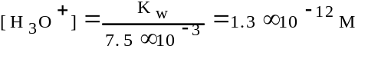
pH = -log [H₃O⁺] = 11.89
(b) 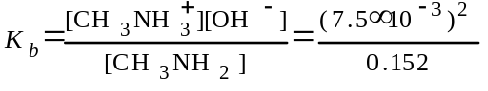
=3.7x10⁻⁴
(c) 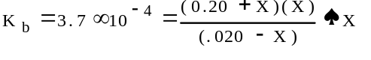
= [OH⁻]
Q = [La³⁺][OH⁻]³ = (0.050)(3.7x10⁻⁴)³
= 2.5x10⁻¹²
Q > K_{sp}, therefore, La(OH)₃ precipitates

1981 D
Al(NO₃)₃ K₂CO₃ NaHSO₄ NH₄Cl
(a) Predict whether a 0.10 molar solution of each of the salts above is acidic, neutral or basic.
(b) For each of the solutions that is not neutral, write a balanced chemical equation for a reaction occurring with water that supports your prediction.
Answer:
(a) Al(NO₃)₃ - acidic K₂CO₃ - basic
NaHSO₄ - acidic NH₄Cl - acidic
(b) Al³⁺ + H₂O --> Al(OH)²⁺ + H⁺
Al(H₂O)₆³⁺ + H₂O --> [Al(H₂O)₅OH]²⁺ + H₃O⁺
Al³⁺ + 3 H₂O --> Al(OH)₃ + 3 H⁺
CO₃²⁻ + H₂O --> HCO₃⁻ + OH⁻
HSO₄⁻ + H₂O --> SO₄²⁻ + H₃O⁺
NH₄⁺ + H₂O --> NH₃ + H₃O⁺

1982 A
A buffer solution contains 0.40 mole of formic acid, HCOOH, and 0.60 mole of sodium formate, HCOONa, in 1.00 litre of solution. The ionization constant, K_{a}, of formic acid is 1.8x10⁻⁴.
(a) Calculate the pH of this solution.
(b) If 100. millilitres of this buffer solution is diluted to a volume of 1.00 litre with pure water, the pH does not change. Discuss why the pH remains constant on dilution.
(c) A 5.00 millilitre sample of 1.00 molar HCl is added to 100. millilitres of the original buffer solution. Calculate the [H₃O⁺] of the resulting solution.
(d) A 800.-milliliter sample of 2.00-molar formic acid is mixed with 200. milliliters of 4.80-molar NaOH. Calculate the [H₃O⁺] of the resulting solution.
Answer:
(a) using the Henderson-Hasselbalch equation
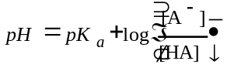
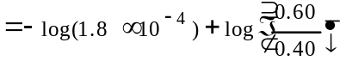
= 3.92 {other approaches possible}
(b) The pH remains unchanged because the ratio of the formate and formic acid concentration stays the same.
(c) initial concentrations
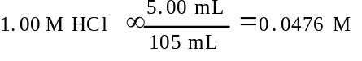
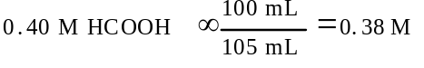
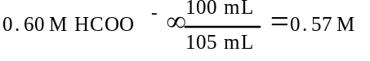
concentrations after H⁺ reacts with HCOO⁻
0.38M + 0.05M = 0.43M HCOOH
0.57M - 0.05M = 0.52M HCOO⁻
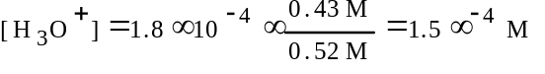
(d) 0.800L × 2.00M HCOOH = 1.60 mol
0.200L × 4.80M NaOH = 0.96 mol OH⁻
at equil., (1.60 - 0.96) = 0.64 mol HCOOH and 0.96 mol HCOO⁻
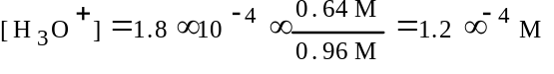

1982 D
A solution of barium hydroxide is titrated with 0.1-M sulfuric acid and the electrical conductivity of the solution is measured as the titration proceeds. The data obtained are plotted on the graph below.
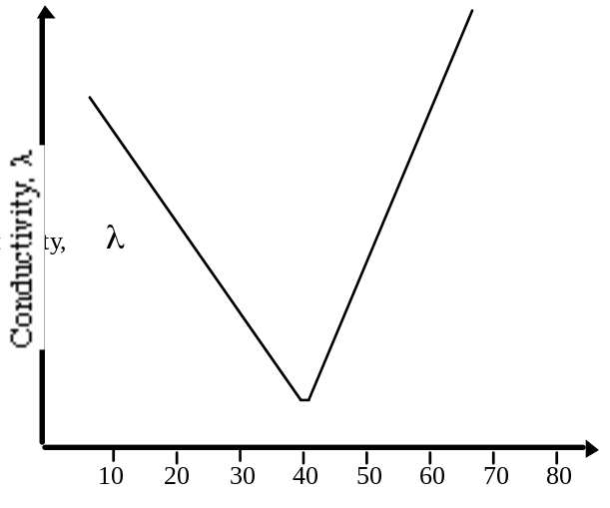
Millilitres of 0.1-M H₂SO₄
(a) For the reaction that occurs during the titration described above, write a balanced net ionic equation.
(b) Explain why the conductivity decreases, passes through a minimum, and then increases as the volume of H₂SO₄ added to the barium hydroxide is increased.
(c) Calculate the number of moles of barium hydroxide originally present in the solution that is titrated.
(d) Explain why the conductivity does not fall to zero at the equivalence point of this titration.
Answer:
(a) Ba²⁺ + 2 OH⁻ + 2 H⁺ + SO₄²⁻ --> BaSO₄(s) + 2 H₂O
(b) The initial conductivity is high because of the presence of Ba²⁺ and OH⁻ ions. The conductivity decreases because Ba²⁺ forms insoluble BaSO₄ with the addition of SO₄²⁻. The conductivity also decreases because OH⁻ combines with the addition of H⁺ ions by forming H₂O.
Beyond the equivalence point conductivity increases as H⁺ and SO₄²⁻ ions are added.
(c) # mol Ba(OH)₂ = # mol H₂SO₄
=0.1M × 0.04L = 0.004 mol
(d) BaSO₄(s) dissociates slightly to form Ba²⁺ and SO₄²⁻, while the water ionizes slightly to form H⁺ and OH⁻.

1983 B
The molecular weight of a monoprotic acid HX was to be determined. A sample of 15.126 grams of HX was dissolved in distilled water and the volume brought to exactly 250.00 millilitres in a volumetric flask. Several 50.00 millilitre portions of this solution were titrated against NaOH solution, requiring an average of 38.21 millilitres of NaOH.
The NaOH solution was standardized against oxalic acid dihydrate, H₂C₂O₄.2H₂O (molecular weight: 126.066 gram mol⁻¹). The volume of NaOH solution required to neutralize 1.2596 grams of oxalic acid dihydrate was 41.24 millilitres.
(a) Calculate the molarity of the NaOH solution.
(b) Calculate the number of moles of HX in a 50.00 millilitre portion used for titration.
(c) Calculate the molecular weight of HX.
(d) Discuss the effect of the calculated molecular weight of HX if the sample of oxalic acid dihydrate contained a nonacidic impurity.
Answer:
(a) mol H₂C₂O₄.2H₂O = 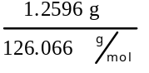 =
9.9916x10⁻³ mol
H₂C₂O₄ + 2 NaOH --> Na₂C₂O₄ + 2 H₂O
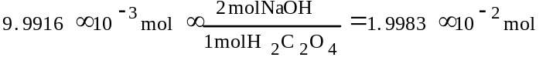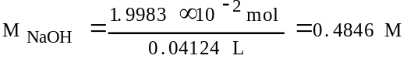
(b) mol HX = mol NaOH
0.03821 L x 0.4846 M = 0.01852 mol HX
(c) 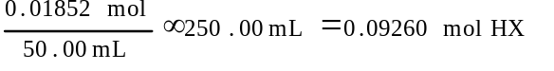
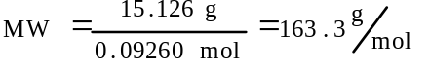
(d) The calculated molecular weight is smaller than true value, because:
measured g H₂C₂O₄ is larger than true value,
calculated mol H₂C₂O₄ is larger than true value,
calculated mol NaOH is larger than true value,
calculated M NaOH is larger than true value
calculated mol HX is larger than true value, therefore,
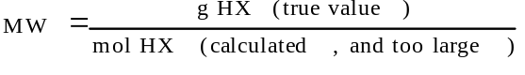

1983 C
(a) Specify the properties of a buffer solution. Describe the components and the composition of effective buffer solutions.
(b) An employer is interviewing four applicants for a job as a laboratory technician and asks each how to prepare a buffer solution with a pH close to 9.
Archie A. says he would mix acetic acid and sodium acetate solutions.
Beula B. says she would mix NH₄Cl and HCl solutions.
Carla C. says she would mix NH₄Cl and NH₃ solutions.
Dexter D. says he would mix NH₃ and NaOH solutions.
Which of these applicants has given an appropriate procedure? Explain your answer, referring to your discussion in part (a). Explain what is wrong with the erroneous procedures.
(No calculations are necessary, but the following acidity constants may be helpful: acetic acid, K_{a}= 1.8x10⁻⁵; NH₄⁺, K_{a} = 5.6x10⁻¹⁰)
Answer:
(a) A buffer solution resists changes in pH upon the addition of an acid or base.
Preparation of a buffer: (1) mix a weak acid + a salt of a weak acid; or (2) mix a weak base + salt of a weak base; or (3) mix a weak acid with about half as many moles of strong base; or (4) mix a weak base with about half as many moles of strong acid; or (5) mix a weak acid and a weak base.
(b) Carla has the correct procedure, she has mixed a weak base, NH₃, with the salt of a weak base, NH₄Cl.
Archie has a buffer solution but a pH of around 5.
Beula doesn’t have a buffer solution, her solution consists of a strong acid and a salt of a weak base.
Dexter does not have a buffer solution, since his solution consists of a weak base plus a strong base.

1984 A
Sodium benzoate, C₆H₅COONa, is the salt of a the weak acid, benzoic acid, C₆H₅COOH. A 0.10 molar solution of sodium benzoate has a pH of 8.60 at room temperature.
(a) Calculate the [OH⁻] in the sodium benzoate solution described above.
(b) Calculate the value for the equilibrium constant for the reaction:
C₆H₅COO⁻ + H₂O <=> C₆H₅COOH + OH⁻
(c) Calculate the value of K_{a}, the acid dissociation constant for benzoic acid.
(d) A saturated solution of benzoic acid is prepared by adding excess solid benzoic acid to pure water at room temperature. Since this saturated solution has a pH of 2.88, calculate the molar solubility of benzoic acid at room temperature.
Answer:
(a) pH =8.6, pOH =5.4
[OH⁻] =10^{-pOH} = 3.98x10⁻⁶M
(b) [C₆H₅COOH] = [OH⁻]
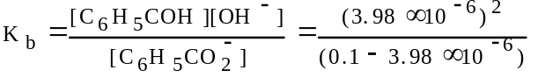
= 1.58x10⁻¹⁰
(c) 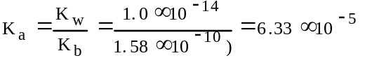
(d) pH 2.88 = 1.32x10⁻³M [H⁺] = [C₆H₅COO⁻]
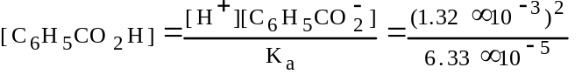
= 2.75x10⁻²M [C₆H₅COOH]
total dissolved = (2.75x10⁻²M + 1.32x10⁻³M as ions)
= 2.88x10⁻²M

1984 C
Discuss the roles of indicators in the titration of acids and bases. Explain the basis of their operation and the factors to be considered in selecting an appropriate indicator for a particular titration.
Answer:
An indicator signals the end point of a titration by changing color.
An indicator is a weak acid or weak base where the acid form and basic form of the indicators are of different colors.
An indicator changes color when the pH of the solution equals the pKa of the indicator. In selecting an indicator, the pH at which the indicator changes color should be equal to (or bracket) the pH of the solution at the equivalence point.
For example, when a strong acid is titrated with a strong base, the pH at the equivalence point is 7, so we would choose an indicator that changes color at a pH = 7. {Many other examples possible.}

1986 A
In water, hydrazoic acid, HN₃, is a weak acid that has an equilibrium constant, K_{a}, equal to 2.8x10⁻⁵ at 25ºC. A 0.300 litre sample of a 0.050 molar solution of the acid is prepared.
(a) Write the expression for the equilibrium constant, K_{a}, for hydrazoic acid.
(b) Calculate the pH of this solution at 25ºC.
(c) To 0.150 litre of this solution, 0.80 gram of sodium azide, NaN₃, is added. The salt dissolved completely. Calculate the pH of the resulting solution at 25ºC if the volume of the solution remains unchanged.
(d) To the remaining 0.150 litre of the original solution, 0.075 litre of 0.100 molar NaOH solution is added. Calculate the [OH⁻] for the resulting solution at 25ºC.
Answer:
(a) HN₃ <=> H⁺ + N₃⁻
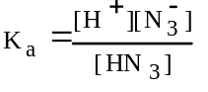
(b) [H⁺] = [N₃⁻] = X
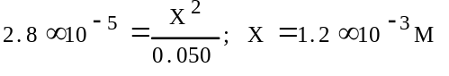
pH = -log[H⁺] = 2.93
(c) 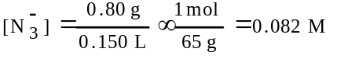
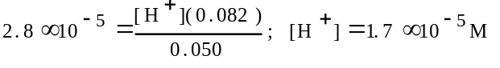
pH = 4.77
(d) (0.075L)(0.100M) = 0.0075 mol NaOH
(0.150L)(0.050M) = 0.0075 mol HN₃
OH⁻ + HN₃ --> H₂O + N₃⁻ ; neut. complete
N₃⁻ + H₂O <=> HN₃ + OH⁻ ; 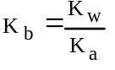
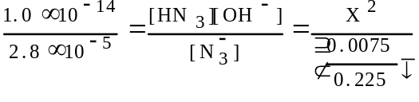
X = [OH⁻] = 3.5x10⁻⁶M

1986 D
H₂SO₃ HSO₃⁻ HClO₄ HClO₃ H₃BO₃
Oxyacids, such as those above, contain an atom bonded to one or more oxygen atoms; one or more of these oxygen atoms may also be bonded to hydrogen.
(a) Discuss the factors that are often used to predict correctly the strengths of the oxyacids listed above.
(b) Arrange the examples above in the order of increasing acid strength.
Answer:
(a) 1) As effective nuclear charge on central atom increases, acid strength increases. OR
As number of lone oxygen atoms (oxygen atoms not bonded to hydrogen) increases, acid strength increases. OR
As electronegativity of central atom increases, acid strength increases.
2) Loss of H⁺ by a neutral acid molecule reduces acid strength. OR
K_{a} of H₂SO₃ > K_{a} of HSO₃⁻
(b) H₃BO₃ < HSO₃⁻ < H₂SO₃ < HClO₃ < HClO₄
H₃BO₃ or HSO₃⁻ weakest (must be together)

1987 A
NH₃ + H₂O <=> NH₄⁺ + OH⁻ Ammonia is a weak base that dissociates in water as shown above. At 25ºC, the base dissociation constant, K_{b}, for NH₃ is 1.8x10⁻⁵.
(a) Determine the hydroxide ion concentration and the percentage dissociation of a 0.150 molar solution of ammonia at 25ºC.
(b) Determine the pH of a solution prepared by adding 0.0500 mole of solid ammonium chloride to 100. millilitres of a 0.150 molar solution of ammonia.
(c) If 0.0800 mole of solid magnesium chloride, MgCl₂, is dissolved in the solution prepared in part (b) and the resulting solution is well-stirred, will a precipitate of Mg(OH)₂ form? Show calculations to support your answer. (Assume the volume of the solution is unchanged. The solubility product constant for Mg(OH)₂ is 1.5x10⁻¹¹.
Answer:
(a) [NH₄⁺] = [OH⁻] = X; [NH₃] = (0.150 - X)
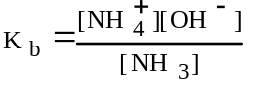 ; 1.8x10⁻⁵ = 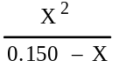
X= [OH⁻] = 1.6x10⁻³ M
% diss. = 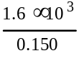 x 100% = 1.1%
(b) [NH₄⁺] = 0.0500 mol/0.100L = 0.500M
[NH₃] = 0.150M
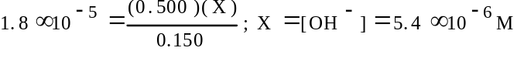
pOH = 5.27; pH = (14 - 5.27) = 8.73
(c) Mg(OH)₂ <=> Mg²⁺ + 2 OH⁻
[Mg²⁺] = (0.0800mol/0.100L) = 0.800M
[OH⁻] = 5.4x10⁻⁶M
Q = [Mg²⁺][OH⁻]² = (0.800)(5.4x10⁻⁶)²
= 2.3x10⁻¹¹
Q > K_{sp} so Mg(OH)₂ precipitates

1987 B
The percentage by weight of nitric acid, HNO₃, in a sample of concentrated nitric acid is to be determined.
(a) Initially a NaOH solution was standardized by titration with a sample of potassium hydrogen phthalate, KHC₈H₄O₄, a monoprotic acid often used as a primary standard. A sample of pure KHC₈H₄O₄ weighing 1.518 grams was dissolved in water and titrated with the NaOH solution. To reach the equivalence point, 26.90 millilitres of base was required. Calculate the molarity of the NaOH solution. (Molecular weight: KHC₈H₄O₄ = 204.2)
(b) A 10.00 millilitre sample of the concentrated nitric acid was diluted with water to a total volume of 500.00 millilitres. Then 25.00 millilitres of the diluted acid solution was titrated with the standardized NaOH solution prepared in part (a). The equivalence point was reached after 28.35 millilitres of the base had been added. Calculate the molarity of the concentrated nitric acid.
(c) The density of the concentrated nitric acid used in this experiment was determined to be 1.42 grams per millilitre. Determine the percentage by weight of HNO₃ in the original sample of concentrated nitric acid.
Answer:
(a) 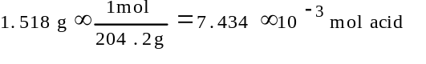
= mol NaOH required to neut.
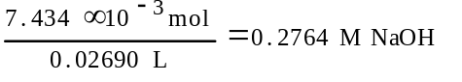
(b) 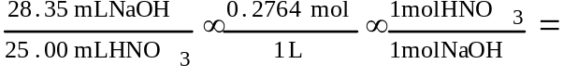
= 0.3134M HNO₃
M_{f}V_{f}=M_{i}V_{i};(0.3134M)(500mL) = (M)(10.00mL)
M = 15.67M HNO₃
(c) 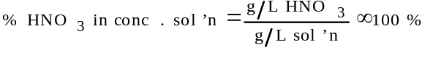
grams HNO₃ in 1 L conc. solÆn =
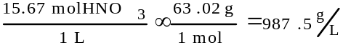
grams sol’n in 1 L conc. Sol’n
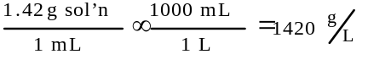
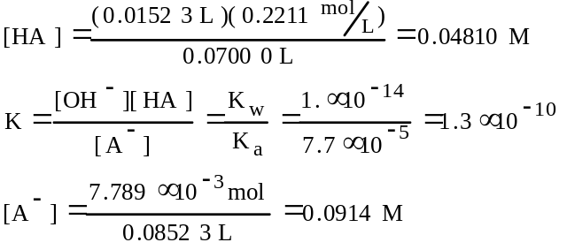

1988 D
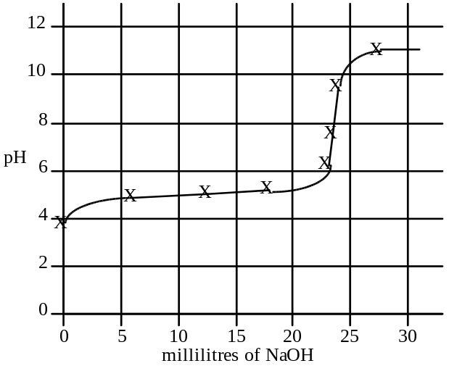
A 30.00 millilitre sample of a weak monoprotic acid was titrated with a standardized solution of NaOH. A pH meter was used to measure the pH after each increment of NaOH was added, and the curve above was constructed.
(a) Explain how this curve could be used to determine the molarity of the acid.
(b) Explain how this curve could be used to determine the dissociation constant K_{a} of the weak monoprotic acid.
(c) If you were to repeat the titration using a indicator in the acid to signal the endpoint, which of the following indicators should you select? Give the reason for your choice.
Methyl red K_{a} = 1x10⁻⁵
Cresol red K_{a} = 1x10⁻⁸
Alizarin yellow K_{a} = 1x10⁻¹¹
(d) Sketch the titration curve that would result if the weak monoprotic acid were replaced by a strong monoprotic acid, such as HCl of the same molarity. Identify differences between this titration curve and the curve shown above.
Answer:
(a) The sharp vertical rise in pH on the pH-volume curve appears at the equivalence point (about 23 mL). Because the acid is monoprotic, the number of moles of acid equals the number of moles of NaOH. That number is the product of the exact volume and the molarity of the NaOH. The molarity of the acid is the number of moles of the acid divided by 0.30L, the volume of the acid.
(b) At the half-equivalence point (where the volume of the base added is exactly half its volume at the equivalence point), the concentration [HX] of the weak acid equals the concentration [X⁻] of its anion. Thus, in the equilibrium expression [H⁺][X⁻]/[HX] = K_{a}, [H⁺] = K_{a}. Therefore, pH at the half-equivalence point equals pK_{a}.
(c) Cresol red is the best indicator because its pK_{a} (about 8) appears midway in the steep equivalence region. This insures that at the equivalence point the maximum color change for the minimal change in the volume of NaOH added is observed.
(d)
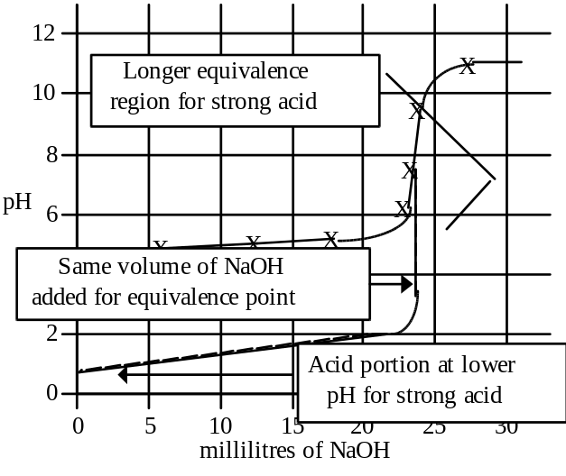

1989 A
In an experiment to determine the molecular weight and the ionization constant for ascorbic acid (vitamin C), a student dissolved 1.3717 grams of the acid in water to make 50.00 millilitres of solution. The entire solution was titrated with a 0.2211 molar NaOH solution. The pH was monitored throughout the titration. The equivalence point was reached when 35.23 millilitres of the base has been added. Under the conditions of this experiment, ascorbic acid acts as a monoprotic acid that can be represented as HA.
(a) From the information above, calculate the molecular weight of ascorbic acid.
(b) When 20.00 millilitres of NaOH had been added during the titration, the pH of the solution was 4.23. Calculate the acid ionization constant for ascorbic acid.
(c) Calculate the equilibrium constant for the reaction of the ascorbate ion, A⁻, with water.
(d) Calculate the pH of the solution at the equivalence point of the titration.
Answer:
(a) (0.2211M)(0.03523L) = 7.789x10⁻³ mol
1.3717g/7.789x10⁻³ mol = 176.1g/mol
(b) at pH 4.23, [H⁺] = 8.0x10⁻⁸M
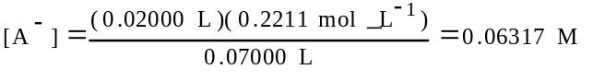
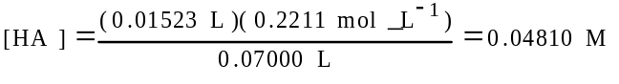
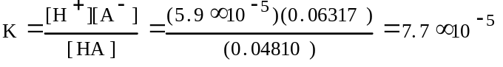
(c) A⁻ + H₂O <=> HA + OH⁻
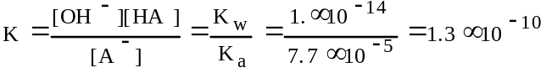
(d) at equiv. pt.
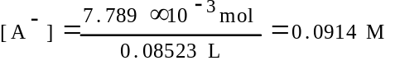
[OH⁻]² = (1.3x10⁻¹⁰)(9.14x10⁻²) = 1.2x10⁻¹¹
[OH⁻] = 3.4x10⁻⁶M
pOH =-log(3.4x10⁻⁶) =5.47; pH = (14-5.47)= 8.53

1990 D
Give a brief explanation for each of the following.
(a) For the diprotic acid H₂S, the first dissociation constant is larger than the second dissociation constant by about 10⁵ (K₁ ~ 10⁵ K₂).
(b) In water, NaOH is a base but HOCl is an acid.
(c) HCl and HI are equally strong acids in water but, in pure acetic acid, HI is a stronger acid than HCl.
(d) When each is dissolved in water, HCl is a much stronger acid than HF.
Answer:
(a) After the first H⁺ is lost from H₂S, the remaining species, HS⁻, has a negative charge. This increases the attraction of the S atom for the bonding electrons in HS⁻. Therefore, the bond is stronger, H⁺ is harder to remove, and K₂ is lower.
(b) Polar H₂O can separate ionic NaOH into Na⁺(aq) and OH⁻(aq), giving a basic solution. In HOCl, chlorine has a high attraction for electrons due to its greater charge density. This draws electrons in the H-O bond towards it and weakens the bond. H⁺ can be removed, making an acidic solution.
(c) Water is a more basic solvent (greater attraction for H⁺) and removes H⁺ from HCl and HI equally.
Acetic acid has little attraction for H⁺, but the H⁺ separates from the larger I⁻ more easily than from the smaller Cl⁻.
(d) The bond between H and Cl is weaker than the bond between H and F. Therefore, HCl is a stronger acid.

1991 A
The acid ionization constant, K_{a}, for propanoic acid, C₂H₅COOH, is 1.3x10⁻⁵.
(a) Calculate the hydrogen ion concentration, [H⁺], in a 0.20-molar solution of propanoic acid.
(b) Calculate the percentage of propanoic acid molecules that are ionized in the solution in (a).
(c) What is the ratio of the concentration of propanoate ion, C₂H₅COO⁻, to that of propanoic acid in a buffer solution with a pH of 5.20?
(d) In a 100.-milliliter sample of a different buffer solution, the propanoic acid concentration is 0.35-molar and the sodium propanoate concentration is 0.50-molar. To this buffer solution, 0.0040 mole of solid NaOH is added. Calculate the pH of the resulting solution.
Answer:
(a) 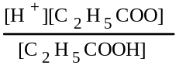 = K_{a}
[H⁺] = [C₂H₅COO⁻] = X
[C₂H₅COOH] = 0.20 M - X
assume X is small, ?, 0.20 - X ~ 0.20
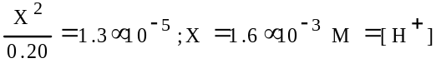
(b) from (a), X = amount of acid that ionized, therefore,
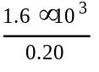 x 100% = 0.81% ionized
(c) @ pH 5.20, [H⁺] = antilog (-5.20) = 6.31x10⁻⁶ M
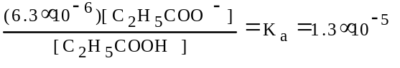
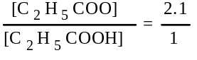
OR
(c) Henderson-Hasselbalch
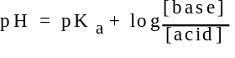
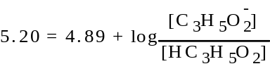
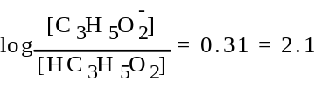
(d) [C₂H₅COO⁻] = 0.50 M; [C₂H₅COOH] = 0.35 M
[OH-] = 0.0040 mol/0.100 L = 0.040 M
this neutralizes 0.04 M of the acid, giving [C₂H₅COOH] = 0.31 M and the propanoate ion increases by a similar amount to 0.54 M.
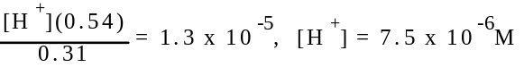
pH = - log [H⁺] = 5.13
OR
(d) using [ ]’s or moles of propanoic acid and propanoate ion...
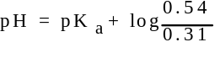
= 4.89 + 0.24 = 5.13

1992 D
The equations and constants for the dissociation of three different acids are given below.
HCO₃⁻ <=> H⁺ + CO₃²⁻ K_{a} = 4.2 x 10⁻⁷
H₂PO₄⁻ <=> H⁺ + HPO₄²⁻ K_{a} = 6.2 x 10⁻⁸
HSO₄⁻ <=> H⁺ + SO₄²⁻ K_{a} = 1.3 x 10⁻²
(a) From the systems above, identify the conjugate pair that is best for preparing a buffer with a pH of 7.2. Explain your choice.
(b) Explain briefly how you would prepare the buffer solution described in (a) with the conjugate pair you have chosen.
(c) If the concentrations of both the acid and the conjugate base you have chosen were doubled, how would the pH be affected? Explain how the capacity of the buffer is affected by this change in concentrations of acid and base.
(d) Explain briefly how you could prepare the buffer solution in (a) if you had available the solid salt of the only one member of the conjugate pair and solution of a strong acid and a strong base.
Answer:
(a) Best conjugate pair: H₂PO₄⁻, HPO₄²⁻. When 7.2 = pH = pK_{a} for this pair when [H₂PO₄⁻] = [HPO₄²⁻].
(b) Dissolve equal moles (or amounts) of H₂PO₄⁻, and HPO₄²⁻ (or appropiate compounds) in water.
(c) pH not changed. Capacity of buffer would increase because there are more moles of conjugate acid and conjugate base to react with added base or acid.
(d) Add strong base to salt of conjugate acid OR add strong acid to salt of conjugate base.
Add 1 mole conjugate acid to 1/2 mole strong base OR 1 mole conjugate base to 1/2 mole strong acid.
OR
Use pH meter to monitor addition of strong base to conjugate acid OR strong acid to conjugate base.

1993 A
CH₃NH₂ + H₂O <=> CH₃NH₃⁺ + OH⁻
Methylamine, CH₃NH₂, is a weak base that reacts according to the equation above. The value of the ionization constant, K_{b}, is 5.25x10⁻⁴. Methylamine forms salts such as methylammonium nitrate, (CH₃NH₃⁺)(NO₃⁻).
(a) Calculate the hydroxide ion concentration, [OH⁻], of a 0.225-molar aqueous solution of methylamine.
(b) Calculate the pH of a solution made by adding 0.0100 mole of solid methylammonium nitrate to 120.0 milliliters of a 0.225-molar solution of methylamine. Assume no volume change occurs.
(c) How many moles of either NaOH or HCl (state clearly which you choose) should be added to the solution in (b) to produce a solution that has a pH of 11.00? Assume that no volume change occurs.
(d) A volume of 100. milliliters of distilled water is added to the solution in (c). How is the pH of the solution affected? Explain.
Answer:
(a) 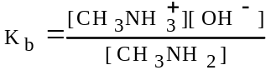
CH₃NH₂ + H₂O <=> CH₃NH₃⁺ + OH⁻
[ ]_{i} 0.225 0 0
Δ[ ] -X +X +X
[ ]_{eq} 0.225-X X X
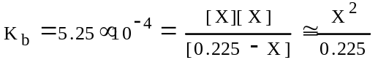
X = [OH⁻] = 1.09x10⁻² M
solved using quadratic: X = [OH⁻] = 1.06x10⁻² M
(b) [CH₃NH₃⁺] = 0.0100 mol / 0.1200 L = 0.0833 M
or CH₃NH₂ = 0.120 L x 0.225 mol/L = 0.0270 mol
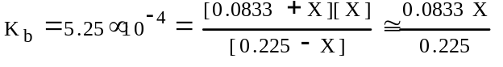
X = [OH⁻] = 1.42x10⁻³ M; pOH = 2.85; pH = 11.15
OR
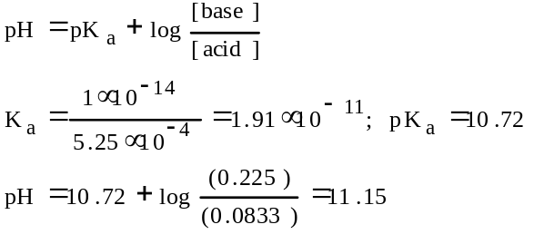
OR
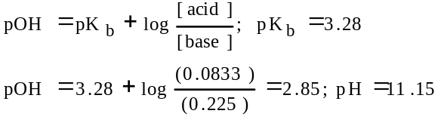
(c) HCl must be added.
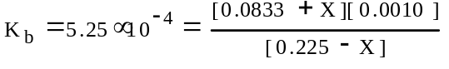
X = 0.0228 M
0.0228 mol/L x 0.120 L = 2.74x10⁻³ mol HCl
OR
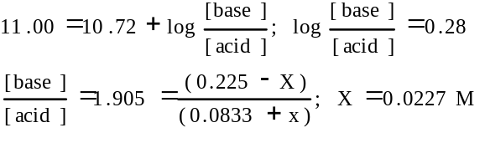
0.0227 M x 0.120 L = 2.73x10⁻³ mol HCl
(d) The 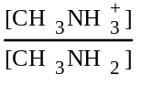 ratio does not change in this buffer solution with dilution, therefore, no effect on pH.

1993 D (Required)
The following observations are made about reaction of sulfuric acid, H₂SO₄. Discuss the chemical processes involved in each case. Use principles from acid-base theory, oxidation-reduction, and bonding and/or intermolecular forces to support your answers.
(a) When zinc metal is added to a solution of dilute H₂SO₄, bubbles of gas are formed and the zinc disappears.
(b) As concentrated H₂SO₄ is added to water, the temperature of the resulting mixture rises.
(c) When a solution of Ba(OH)₂ is added to a dilute H₂SO₄ solution, the electrical conductivity decreases and a white precipitate forms.
(d) When 10 milliliters of 0.10-molar H₂SO₄ is added to 40 milliliters of 0.10-molar NaOH, the pH changes only by about 0.5 unit. After 10 more milliliters of 0.10-molar H₂SO₄ is added, the pH changes about 6 units.
Answer:
(a) Zn is oxidized to Zn²⁺ by H⁺ which in turn is reduced by Zn to H₂. Identify H₂(g) or Zn dissolving as Zn²⁺.
Zn(s) + 2 H⁺(aq) --> Zn²⁺(aq) + H₂(g)
Explicit: Redox or e- transfer or correctly identify oxidizing agent or reducing agent.
(b) H₂SO₄ dissociates, forms ions or dydration ôeventö. Bonds form, therefore, energy given off (connection).
(c) BaSO₄ (ppt) forms or H⁺ + OH⁻ form water. Newly formed water and ppt remove ions lowering conductivity.
Ba²⁺(aq) + OH⁻(aq) + H⁺(aq) + SO₄²⁻(aq) -->
BaSO₄(s)+ H₂O(l)
(d) First 10 mL produces solution of SO₄²⁻ and OH⁻ or excess OH⁻ or partial neutralization (pH 13.0 --> 12.6). [presence of HSO₄⁻ in solution voids this point]
Second 10 mL produces equivalence where pH decreases (changes) rapidly (pH 12.6 --> 7.0). [pH ôrisesö or wrong graph, if used, voids this point]

1994 D
A chemical reaction occurs when 100. milliliters of 0.200-molar HCl is added dropwise to 100. milliliters of 0.100-molar Na₃P0₄ solution.
(a) Write the two net ionic equations for the formation of the major products.
(b) Identify the species that acts as both a Bronsted acid and as a Bronsted base in the equation in (a), Draw the Lewis electron-dot diagram for this species.
(c) Sketch a graph using the axes provided, showing the shape of the titration curve that results when 100. milliliters of the HCl solution is added slowly from a buret to the Na₃PO₄ solution. Account for the shape of the curve.
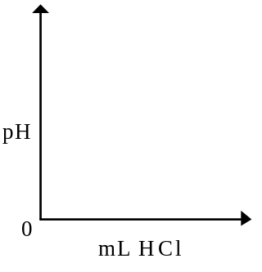
(d) Write the equation for the reaction that occurs if a few additional milliliters of the HCl solution are added to the solution resulting from the titration in (c).
Answer:
(a) PO₄³⁻ + H⁺ --> HPO₄²⁻; HPO₄²⁻ + H⁺ --> H₂PO₄⁻
(b) HPO₄²⁻
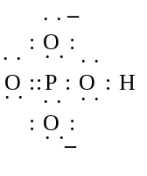
(c) 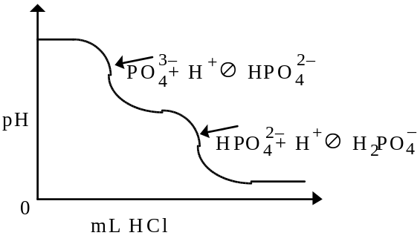
(d) H⁺ + H₂PO₄⁻ --> H₃PO₄

1996 A
HOCl <=> OCl⁻ + H⁺
Hypochlorous acid, HOCl, is a weak acid commonly used as a bleaching agent. The acid-dissociation constant, K_{a}, for the reaction represented above is 3.2x10⁻⁸.
(a) Calculate the [H⁺] of a 0.14-molar solution of HOCl.
(b) Write the correctly balanced net ionic equation for the reaction that occurs when NaOCl is dissolved in water and calculate the numerical value of the equilibrium constant for the reaction.
(c) Calculate the pH of a solution made by combining 40.0 milliliters of 0.14-molar HOCl and 10.0 milliliters of 0.56-molar NaOH.
(d) How many millimoles of solid NaOH must be added to 50.0 milliliters of 0.20-molar HOCl to obtain a buffer solution that has a pH of 7.49? Assume that the addition of the solid NaOH results in a negligible change in volume.
(e) Household bleach is made by dissolving chlorine gas in water, as represented below.
Cl₂(g) + H₂O --> H⁺ + Cl⁻ + HOCl(aq)
Calculate the pH of such a solution if the concentration of HOCl in the solution is 0.065 molar.
Answer:
(a) K_{a} = 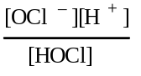 = 3.2x10⁻⁸
X = amount of acid that ionizes = [OCl⁻] = [H⁺]
(0.14 - X) = [HOCl] that remains unionized
3.2x10⁻⁸ = 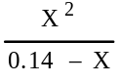 ; X = 6.7x10⁻⁵ M = [H⁺]
(b) NaOCl(s) + H₂O --> Na⁺(aq) + HOCl(aq) + OH⁻(aq)
K_{b} = 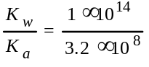 = 3.1x10⁻⁷
(c) [ ]_{o} after dilution but prior to reaction:
[HOCl] = 0.14 M x 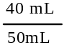 = 0.11 M
[OH⁻] = 0.56 M x 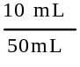 = 0.11 M
Equivalence point reached. [OH⁻] ~ [HOCl]
K_{b} = 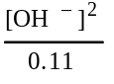 = 3.1x10⁻⁷
[OH⁻] = 1.8x10⁻⁴ ; pOH = 3.7
pH = 14 - 3.7 = 10.3
(d) at pH 7.49, the [H⁺] = 10^{-7.49} = 3.24x10⁻⁸ M
when the solution is half-neutralized, pH = pK_{a} and 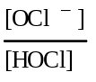 = 1
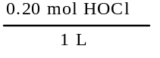 x 50.0 mL = 10.0 mmol HOCl
half this amount, or 5.0 mmol of NaOH added.
(e) 1 mol H+ for every 1 mole of HOCl produced
[H⁺] ~ [HOCl] = 0.065 M
pH = - log (0.065) = 1.2

1997 A
The overall dissociation of oxalic acid, H₂C₂O₄, is represented below. The overall dissociation constant is also indicated.
H₂C₂O₄ <=> 2 H⁺ + C₂O₄²⁻ K = 3.78x10⁻⁶
(a) What volume of 0.400-molar NaOH is required to neutralize completely a 5.00x10⁻³-mole sample of pure oxalic acid?
(b) Give the equations representing the first and second dissociations of oxalic acid. Calculate the value of the first dissociation constant, K₁, for oxalic acid if the value of the second dissociation constant, K₂, is 6.40x10⁻⁵.
(c) To a 0.015-molar solution of oxalic acid, a strong acid is added until the pH is 0.5. Calculate the [C₂O₄²⁻] in the resulting solution. (Assume the change in volume is negligible.)
(d) Calculate the value of the equilibrium constant, K_{b}, for the reaction that occurs when solid Na₂C₂O₄ is dissolved in water.
Answer:
(a) 5.00x10⁻³ mol oxalic acid x 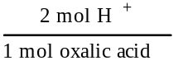 x
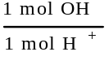 x 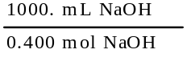 =
= 25.0 mL NaOH
(b) H₂C₂O₄ <=> H⁺ + HC₂O₄⁻
HC₂O₄⁻ <=> H⁺ + C₂O₄²⁻
K = K₁ x K₂
K₁ = 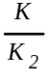 = 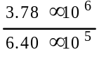 = 5.91x10⁻²
(c) X = amt. ionized
[H₂C₂O₄] = 0.015 - X
[H⁺] = 10^{-pH} = 10^{-0.5} = 0.316 M
[C₂O₄²⁻] = X
K_{a} = 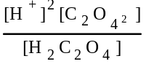 = 3.78x10⁻⁶
3.78x10⁻⁶ = 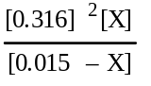 ; X = 5.67x10⁻⁷ M
(d) K_{b} = 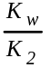 = 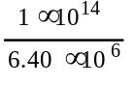 = 1.56x10⁻¹⁰

1998 D (Required) [repeated in lab procedures section]
An approximately 0.1-molar solution of NaOH is to be standardized by titration. Assume that the following materials are available.
• Clean, dry 50 mL buret
• 250 mL Erlenmeyer flask
• Wash bottle filled with distilled water
• Analytical balance
• Phenolphthalein indicator solution
• Potassium hydrogen phthalate, KHP, a pure solid monoprotic acid (to be used as the primary standard)
(a) Briefly describe the steps you would take, using the materials listed above, to standardize the NaOH solution.
(b) Describe (i.e., set up) the calculations necessary to determine the concentration of the NaOH solution.
(c) After the NaOH solution has been standardized, it is used to titrate a weak monoprotic acid, HX. The equivalence point is reached when 25.0 mL of NaOH solution has been added. In the space provided at the right, sketch the titration curve, showing the pH changes that occur as the volume of NaOH solution added increases from 0 to 35.0 mL. Clearly label the equivalence point on the curve.
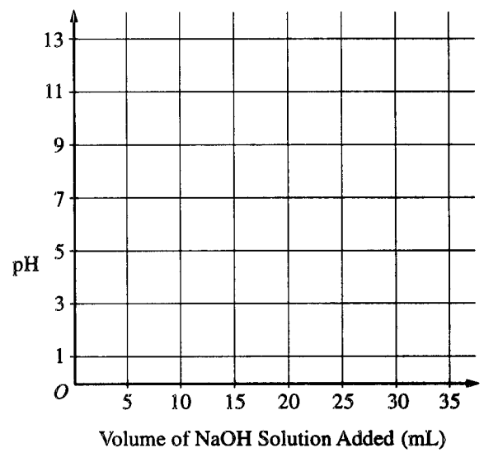
(d) Describe how the value of the acid-dissociation constant, K_{a}, for the weak acid HX could be determined from the titration curve in part (c).
(e) The graph below shows the results obtained by titrating a different weak acid, H₂Y, with the standardized NaOH solution. Identify the negative ion that is present in the highest concentration at the point in the titration represented by the letter A on the curve.
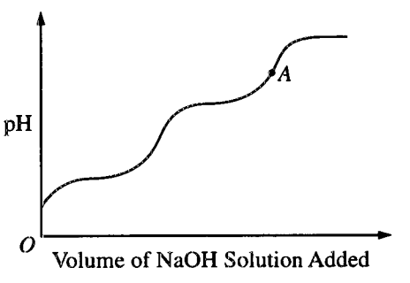
Answer
(a) • exactly mass a sample of KHP in the Erlenmeyer flask and add distilled water to dissolve the solid.
• add a few drops of phenolphthalein to the flask.
• rinse the buret with the NaOH solution and fill.
• record starting volume of base in buret.
• with mixing, titrate the KHP with the NaOH solution until it just turns slightly pink.
• record end volume of buret.
• repeat to check your results.
(b) 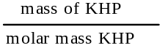 = moles of KHP
since KHP is monoprotic, this is the number of moles of NaOH
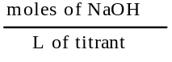 = molarity of NaOH
(c) 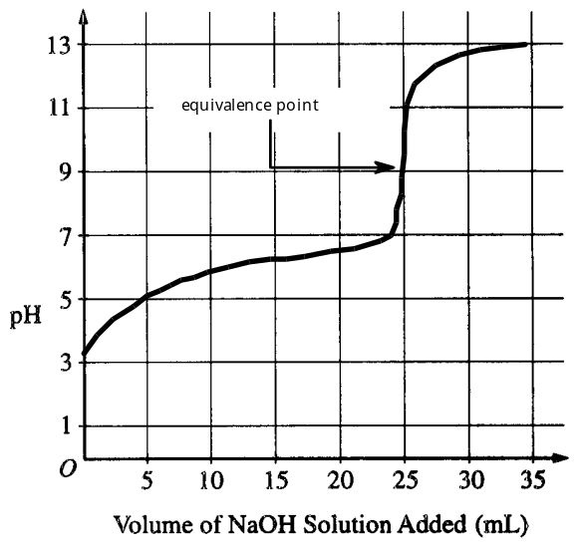
(d) from the titration curve, at the 12.5 mL volume point, the acid is half-neutralized and the pH = pK_{a}. K_{a} = 10^{pK}a
(e) Y²⁻ (could it be OH⁻ ?)

1998 D
Answer each of the following using appropriate chemical principles.
(b) When NH₃ gas is bubbled into an aqueous solution of CuCl₂, a precipitate forms initially. On further bubbling, the precipitate disappears. Explain these two observations.
In each case, justify your choice.
Answer
(b) A small amount of NH₃ in solution causes an increase in the [OH⁻].
NH₃ + H₂O <=> NH₄⁺ + OH⁻
This, in turn, causes the K_{sp} of copper(II) hydroxide to be exceeded and the solution forms a precipitate of Cu(OH)₂.
With the addition of more NH₃, you form the soluble tetraamminecopper(II) complex ion, [Cu(NH₃)₄]²⁺, which will cause the precipitate to dissolve.

1999 A Required
NH3(aq) + H2O(l) ó NH4+(aq) + OH–(aq)
In aqueous solution, ammonia reacts as represented above. In 0.0180 M NH3(aq) at 25ºC, the hydroxide ion concentration, [OH–] is 5.60x10–4 M. In answering the following, assume that temperature is constant at 25ºC and that volumes are additive.
(a) Write the equilibrium-constant expression for the reaction represented above.
(b) Determine the pH of 0.0180 M NH3(aq).
(c) Determine the value of the base ionization constant, Kb, of NH3(aq).
(d) Determine the percent ionization of NH3 in 0.0180 M NH3(aq).
(e) In an experiment, a 20.0 mL sample of 0.0180 M NH3(aq) was placed in a flask and titrated to the equivalence point and beyond using 0.0120 M HCl(aq).
(i) Determine the volume of 0.0120 M HCl(aq) that was added to reach the equivalence point.
(ii) Determine the pH of the solution in the flask after a total of 15.0 mL of 0.0120 M HCl(aq) was added.
(iii) Determine the pH of the solution in the flask after a total of 40.0 mL of 0.0120 M HCl(aq) was added.
Answer
(a) Kb =
(b) pOH = -log(5.60x10–4) = 3.252
pH = 14 – pOH = 10.748
(c) Kb = = 1.80x10–5
(d) x 100% = 3.11%
(e) (i) NAVA = NBVB
(0.0120 N)(VA) = (0.0180 N)(20.0 mL)
VA = 30.0 mL
(ii) at 15.0 mL it is half-titrated and [NH4+] = [NH3], then the Kb = [OH–] = 1.80x10–5.
pOH = -log(1.80x10–5) = 4.745
pH = 14 – 4.75 = 9.255
(iii) at 40.0 mL, there is an excess of 10.0 mL of HCl past equivalence point,
(10.0 mL)(0.0120 M) = 0.120 mmol H+ ions
= 0.00200M =[H+]
pH = -log(0.00200) = 2.70

